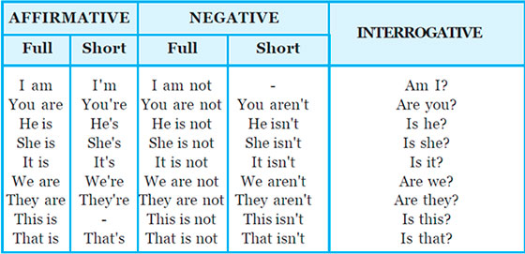**VERB TO BE – SER/ ESTAR**